**Lesson 03 Demo 01**

**Joins**

**Business Scenario:**

Rollin Ford, the regional manager of a retail chain, has to redesign distribution and production strategies. He wants to look at each state's profits along with the managers' names. He also wants to see the number of products returned by customers in each state. You have to combine the data that is stored across different tables and create a visualization to satisfy the above requirement. Rollin wants refresh to happen incrementally based on the date.

* Which is the least profitable state?
* Customers from which state have returned the highest number of products?

**Overview:**

* Combine the Orders, Returns, and People tables
* Use inner join to combine Orders and People tables
* Use the left join between Orders and Returns table
* Create the required view
* Enable mark labels

The result should resemble the following image:

**Detailed Instructions**



**

2.On the home page, under **Connect**, under **To a File**, click **Excel**

3.Browse and connect to the **Sample - Superstore Excel file**

4. Drag and drop **Orders** and **People** tables to the canvas area

5.Make sure the **Inner join** is selected

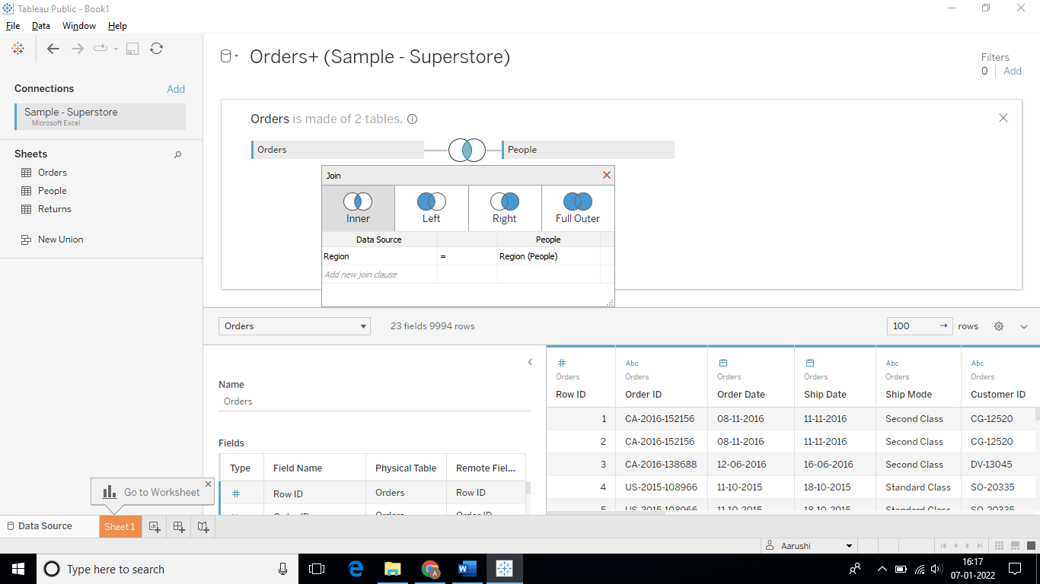

6.Place the **Returns table** in the canvas area and select **Left Join**

7.To create a view, go to **Sheet 1**

8.From Dimensions, locate **State** and **Person** and place them on rows

9.From Measures, locate **Profit** andplace it on columns

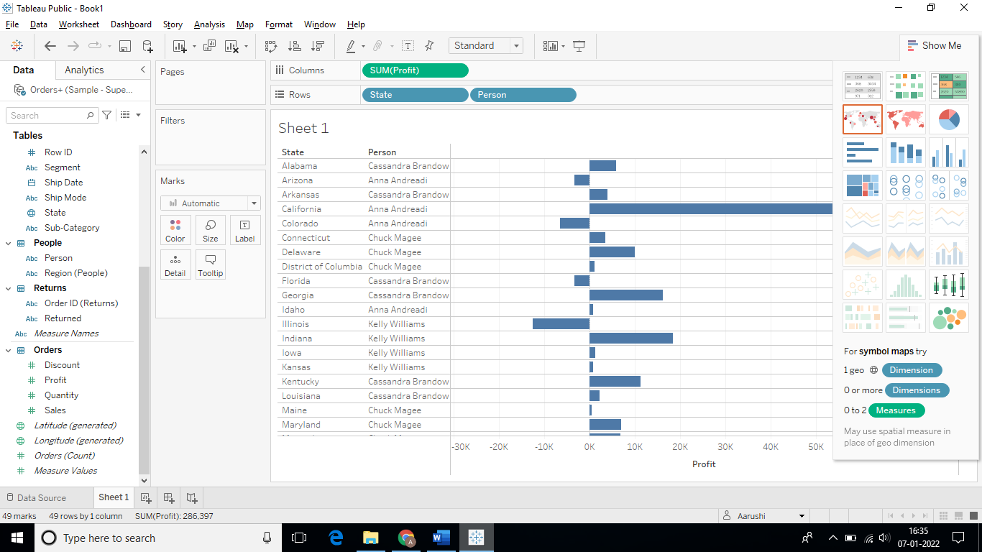

10.On the toolbar, use the **Sort icon** to sort the view in descending order

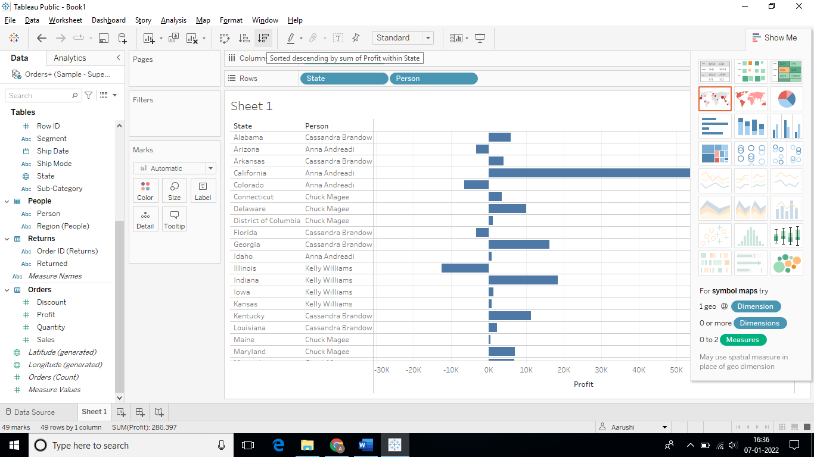

The sorted view is as follows:

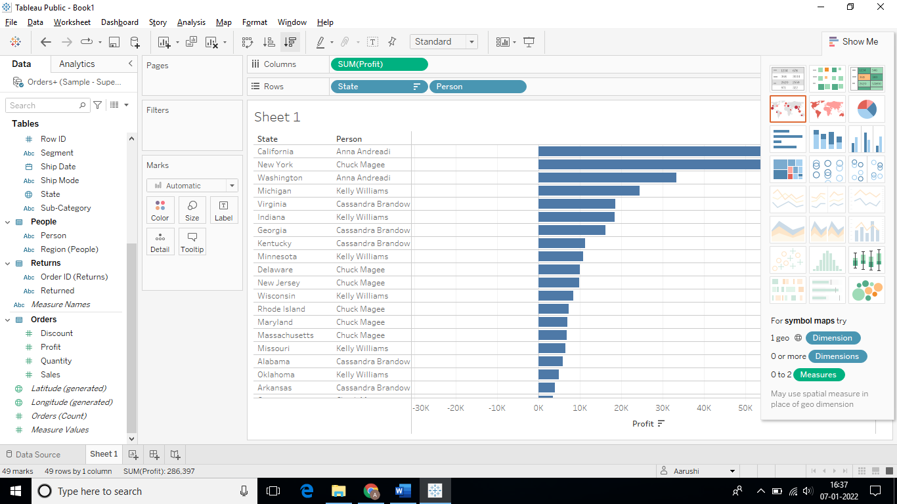

11.To count the number of orders placed, locate **Order ID (Returns)** from Dimensions and place them on columns

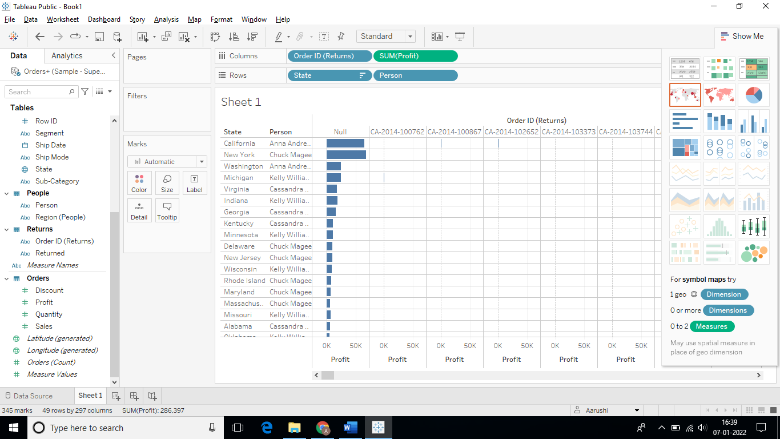

12.Select aggregation as **Count Distinct**

(Right click on **Order ID (Returns)** in **Columns** -> **Measure** -> **Count Distinct)**

The result will be as follows:

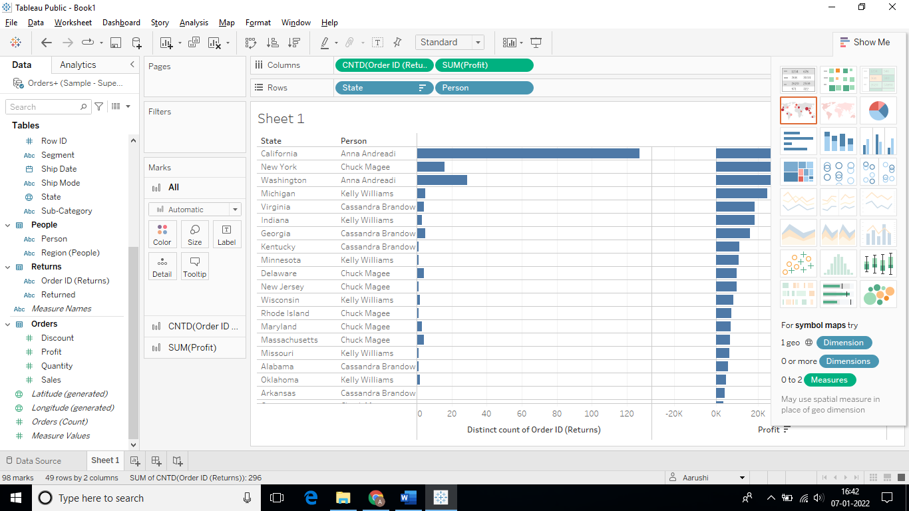

14. Save the workbook as **Lesson 3 – Exercises**

Keep the workbook open to perform the next exercise.

**Answers:**

Based on the view, these are the answers to the questions in the problem statement:

* Which is the least profitable state?

Answer: **Texas**

* Customers from which state have returned the highest number of products?

Answer: **California**